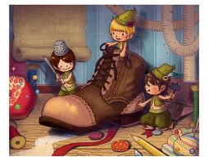
photo Bing.com images
PLEASANT SURPRISE SECRET SOCIETY (PSS Society)

I have chosen the elves and the shoemaker as an emblem for our society.

As you know the aims of the society are to pleasantly surprise someone near to you, anonymously, and make them smile. It is very similar to achieving a good gift for a birthday but with the surprise element that it is not for a birthday.

However one of my own examples was related to a birthday. It concerns the magic chocolate box. Late at night I realised that I had not purchased a present for my wife's birthday, and the only available shop was a coffee shop that opens late but also sells chocolates. I knew that chocolate coated macadamia nuts would be very acceptable and this is what I bought.

The next day however I thought, that was okay but not really brilliant. So I bought a second box of chocolates and kept filling up the first box as they were being eaten one by one. Eventually my wife thought something funny is happening here. It didn't take her long to work it out.

So would you like to join the Pleasant Surprise Secret Society?

Membership requirements are nil, but a story of your own would let you in at senior ranking from the very beginning.

An ambitious idea for the group is that we might take orders to help someone else raise a smile.

Perhaps start your own.

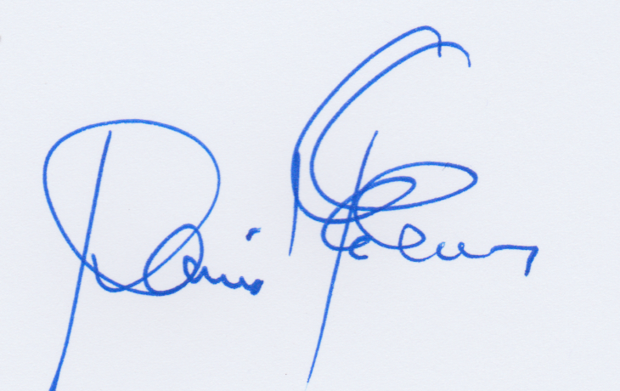

David D E Evans
ddeevans1@gmail.com

